# *~.~*~ Starlight Girls ~*~.~*

# Setup

Before play, place the Deck of Actions in the middle of the table. Then, every player picks what their **Star Sign** is from the list below. No two players can pick the same **Star Sign**.

|  |
| --- |
| **Aquarius** *The Ocean-Healing Magi* |
| **Gemini** *The Fortune-Telling Mystic* |
| **Libra** *The Fire-Spirit Warrior* |

Next, determine which **Enemy** you need to defeat from the Deck of Enemies. For first time players, it is recommended that you select one Enemy card of your choice from the deck. Experienced players can shuffle and draw a random card from the deck if they wish.

# Enemies

Each **Enemy** card has 3 elements: Its **Fortitude**, a **Passive Ability**, and an **Active Ability**.

## Fortitude

**Fortitude** represents how strong your **Enemy** is. As you fight the enemy in combat (detailed later), you will reduce its **Fortitude**. If its **Fortitude** is reduced to zero, that **Enemy** is defeated. Once you defeat your chosen **Enemy**, **You win!**

## Passive Ability

The **Enemy’s Passive Ability** is an additional rule that is in effect while you are in combat with the **Enemy**. It may be something that happens after a certain trigger, an ongoing effect, or any number of things.

## Active Ability

The **Enemy’s Active Ability** is an effect that happens when certain cards are drawn in combat (detailed later). It has an immediate effect, compared to the Passive ability which is an ongoing effect.

# Combat

Before combat starts, each player draws a single card from the Deck of Actions, proceeding in the order that the **Star Signs** are listed in the Setup section. This will also be the turn order for the rest of the game.

The next step is to engage the **Enemy** in combat! Combat consists of rounds. Each round consists of each player taking a turn, going around the table in the same order as before. On a player’s turn, they can do one of three things: **Draw & Play, Trade** or **Help Out**. Once every player has taken a turn, the round ends and the next one begins.

## Draw & Play

If you choose to Draw & Play on your turn, start by drawing another Action card from the Deck of Actions. Then, you must play one of the two cards in your hand.

Most Action cards have an associated **Value**, **Star Sign**, **Action**, and **Star Action**.

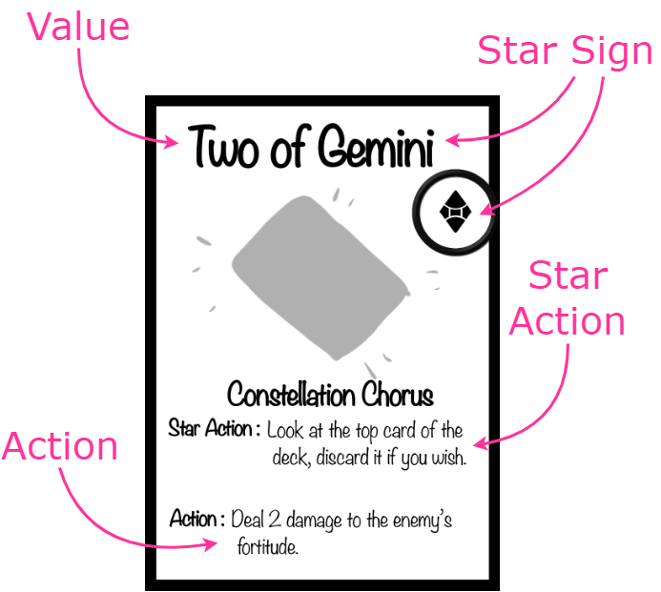

When you play a card, you can use either its **Action** or its **Star Action**. You can only use the **Star Action** if the card’s **Star Sign** matches yours, otherwise, you must use the **Action**.

Some cards don’t have an **Action** or **Star Action**. When these cards are played, all the card text takes effect.

Once a card is played, it is placed in the discard pile. Once the deck runs out, the discard pile is shuffled and added back to the deck.

## Trade

If you choose to Trade on your turn, you can swap the card in your hand with the card in another player’s hand if they agree to the exchange.

## Help Out

If you choose to Help Out on your turn. You can heal one injury from another player instead of drawing or trading.

Two players cannot Help Out directly one after the other.

# Injuries & Defeat

As you fight your **Enemy**, you will accumulate **Injuries**. When you get an Injury, mark it on your **Star Sign Sheet**. You cannot have more than four **Injuries** at any point.

If you ever get four **Injuries** at a time, you are **Defeated**. While **Defeated**, you cannot take turns. However, you are no longer **Defeated** if some or all of your **Injuries** are ever removed. If all players are **Defeated**, you **lose the game!**

# Enemy List

|  |  |
| --- | --- |
| **Moonlight Jester** | |
| **Fortitude** | 80 |
| **Passive Ability** | At the end of each round, players must pass the card in their hand to the player on their left |
| **Active Ability** | Every player must discard the card in their hand and replace it with the top cards of the deck |

|  |  |
| --- | --- |
| **Jupiter** | |
| **Fortitude** | 50 |
| **Passive Ability** | If Jupiter’s **Fortitude** wasn’t reduced during a round, her **Fortitude** increases by 5. |
| **Active Ability** | Jupiter’s **Fortitude** increases by 20. |

|  |  |
| --- | --- |
| **Supernova** | |
| Fortitude | 90 |
| Passive Ability | At the end of the round, the player with the least **Injuries** cannot take a turn next round. If two or more players are tied for least **Injuries**, they can take their turns as normal. |
| Active Ability | Remove one **Injury** from a random player. Every other player takes one **Injury**. |

|  |  |
| --- | --- |
| **Lady Cosmos** | |
| **Fortitude** | 150 |
| **Passive Ability** | Every 3, 5, and 7 card has its card text replaced with:  “Triggers the **Enemy’s Active Ability** and the player who played this card takes one **Injury**.” |
| **Active Ability** | Shuffle all discarded 3, 5, 7, Jack, and King cards back into the deck |

# *~.~*~ Starlight Girls ~*~.~*

Component List

Akshat Rawat, Harrison Meinert-Rita,and Nuha Syed

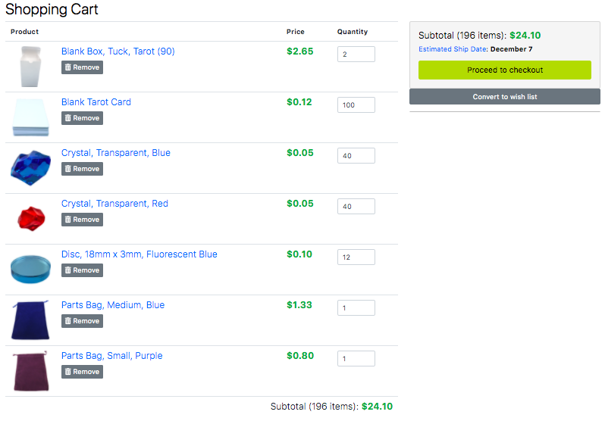

|  |  |  |  |
| --- | --- | --- | --- |
| Component | Quantity | Total Price | Purpose |
| Blank Tarot Cards | 100 | $11.53 | Player & Enemy Cards |
| Red/Blue Crystals | 40 | $1.94 | Injury Tokens |
| Disc Tokens | 12 | $1.25 | Enemy Health Tracker |
| Medium Bag | 1 | $1.33 | Card Storage |
| Small Bag | 1 | $0.80 | Pieces Storage |
| Card Box (90) | 2 | $5.30 | Card Storage Alternative |

**Total Price:** $24.10

# 

|  |  |
| --- | --- |
| **Aquarius** | |
| **Injuries** O O O O | |
| **Star Sign Activation** | |
| Star Sign Activation | Remove all **Injuries** from all players |
| Rising Star Sign Activation | Remove all **Injuries** from all players and reduce an **Enemy’s Fortitude** by 5 times the number of **Injuries** removed |
| **Cards** | |
| 2 | Remove one **Injury** from a player |
| 3 | Remove one **Injury** from a player |
| 4 | Move one **Injury** from one player to another |
| 5 | Move one **Injury** from one player to another |
| 6 | Move one **Injury** from one player to another |
| 7 | Swap the **Injuries** of two different players |
| 8 | Swap the **Injuries** of two different players |
| 9 | Remove all **Injuries** from a player |
| 10 | Remove all **Injuries** from a player |
| Ace | Collect all **Injuries** from all players and redistribute them as you wish |

# 

# 

|  |  |
| --- | --- |
| **Gemini** | |
| **Injuries** O O O O | |
| **Star Sign Activation** | |
| Star Sign Activation | Shuffle all discarded Queen cards (not including this one) back into the deck. |
| Rising Star Sign Activation | Move all discarded Queen cards (not including this one) to the top of the deck in any order you wish. |
| **Cards** | |
| 2 | Look at the top card of the deck, discard it if you wish |
| 3 | Look at the top card of the deck, discard it if you wish |
| 4 | Look at the top 5 cards of the deck |
| 5 | Look at the top 5 cards of the deck |
| 6 | Look at the top 3 cards of the deck and reorder them however you wish |
| 7 | Swap the cards in two different players’ hands |
| 8 | Discard the card in a player’s hand and replace it with the top card of the deck |
| 9 | All players may discard the cards in their hand if they wish and replace them with the top cards of the deck |
| 10 | Move a card from the discard pile to the bottom of the deck |
| Ace | Move a card from the discard pile to any position in the deck |

# 

# 

|  |  |
| --- | --- |
| **Libra** | |
| **Injuries** O O O O | |
| **Star Sign Activation** | |
| Star Sign Activation | Take another 3 turns in a row |
| Rising Star Sign Activation | Take another 5 turns in a row |
| **Cards** | |
| 2 | Reduce the **Enemy’s Fortitude** by 5 and get one **Injury** |
| 3 | Reduce the **Enemy’s Fortitude** by 5 and get one **Injury** |
| 4 | Reduce the **Enemy’s Fortitude** by 10 and get two **Injuries** |
| 5 | Reduce the **Enemy’s Fortitude** by 20 and get three **Injuries** |
| 6 | Discard up to four cards from the top of the deck and reduce the **Enemy’s Fortitude** by the highest value discarded (Jacks count as 12, Kings count as 13, and Queens count as 15) |
| 7 | Reduce the **Enemy’s Fortitude** by the value of the card in your hand (Jacks count as 12, Kings count as 13, and Queens count as 15) |
| 8 | Reduce the **Enemy’s Fortitude** by 5 and take another turn |
| 9 | Reduce the **Enemy’s Fortitude** by 5 and take another turn |
| 10 | Reduce the **Enemy’s Fortitude** by 5 times the number of **Injuries** you have |
| Ace | Reduce the **Enemy’s Fortitude** by 10 times the number of **Injuries** you have |

# 